Nama: Muhammad Luthfi Taufikurrahman

NIM: 2022071053

CREATE TABLE

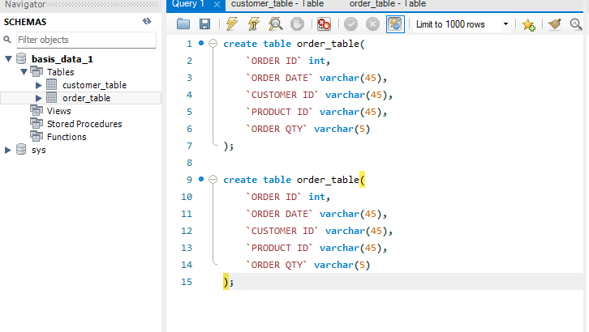

INSERT TABLE

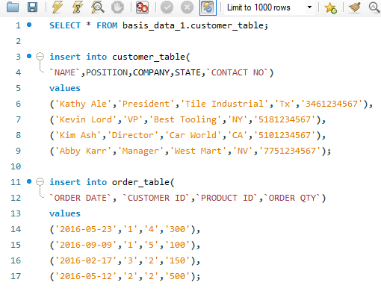

UPDATE TABLE

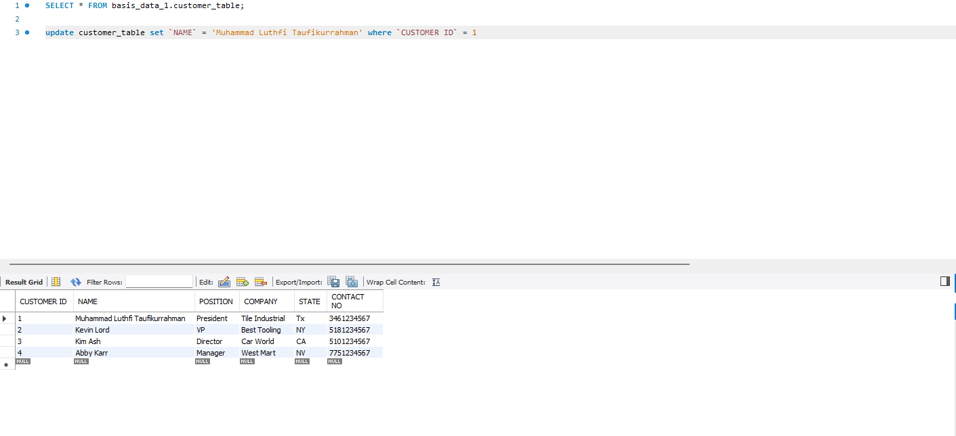

DELETE TABLE

